# WEEKLY REPORT

Summer Internship 2024

Student Name: Dhvani Patel Roll No: 21IT108 Week No: _____**6**______ Duration: __**17/06/2024**__ :____**22/06/2024**____

Company Name: Agevole Innovation Private Limited

Project Name: Agevole Cloud

**Summary of Work done the week (Attach supporting Documents):**

* Completed the development and testing of Terraform scripts for automated AWS EC2 instance provisioning.
* Successfully integrated Terraform with version control, enabling collaborative infrastructure management.
* Established automated deployment pipelines using CI/CD tools, significantly streamlining the EC2 deployment process.

## References:

<https://aws.amazon.com/>

<https://www.terraform.io/>

**Name & Signature**

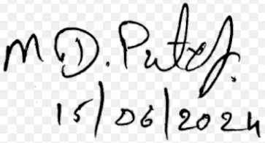

## External Guide Internal Guide